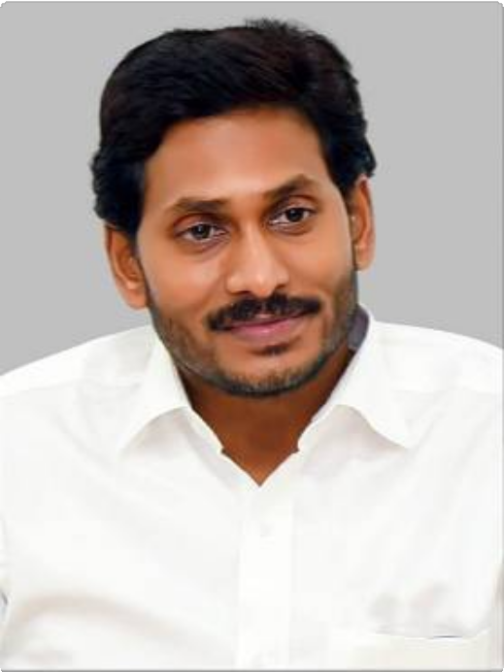

**Sri Y. S. Jagan Mohan Reddy Hon’ble Chief Minister**

**Andhra Pradesh**



[(https://sche.ap.gov.in/)](https://sche.ap.gov.in/)

[(https://iur.ls/careeredge_st)](https://iur.ls/careeredge_st)

[(https://ccelms.ap.gov.in/rusa/user/gpapers)](https://ccelms.ap.gov.in/rusa/user/gpapers)

[(/DOWGR2)](http://www.apcce.gov.in/DOWGR2)

[**Downloads**](http://www.apcce.gov.in/DOWL)

[**Academic Repository**](http://www.apcce.gov.in/DOWGR2)

[**CCE Learning Management System**](https://ccelms.ap.gov.in/rusa/user/gpapers)

[**JKC-TCS iON CAREER SKILLS COURSE**](https://iur.ls/careeredge_st)

[**Click here for Online Admissions 2021-22**](https://sche.ap.gov.in/)

**CCE Web News : Form for uploading Lesson Plan is enabled. Click on Academic Repository for uploading. CCE Web News : F**

[**Data submission : Login for Colleges (/DOWGR1)**](http://www.apcce.gov.in/DOWGR)

[**Data Reports : Login for Colleges (/DOWGR)**](http://www.apcce.gov.in/DOWGR)[**AC-Login (/ACL)**](http://www.apcce.gov.in/ACL)

[(/DOWL)](http://www.apcce.gov.in/DOWL)

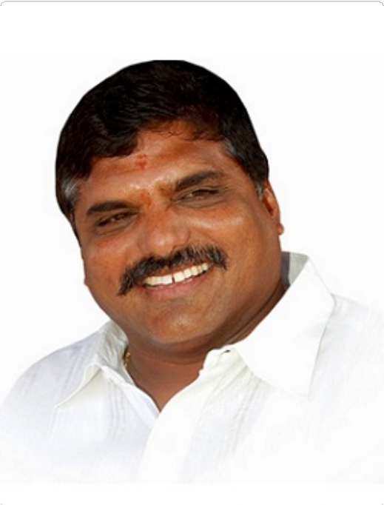

**Sri Botcha Satyanarayana**

**Hon’ble Minister for Education Andhra Pradesh**

ASAR 2021-22 Abstract

ASAR 2021-22 Abstract

**Uploaded so far (Total : 3166**)

|  |  |  |  |  |  |  |  |  |  |  |  |  |  |  |
| --- | --- | --- | --- | --- | --- | --- | --- | --- | --- | --- | --- | --- | --- | --- |
| **S.No** | | **District** | | | | **Name of the College** | | | | | | **Number of**  **Employees** | | |
| 1 | | ANANTAPUR | | | | GDC BUKKAPATNAM | | | | | | 9 | | |
| 2 | | ANANTAPUR | | | | GDC HINDUPUR | | | | | | 12 | | |
| 3 | | ANANTAPUR | | | | GDC KALYANDURG | | | | | | 28 | | |
| 4 | | ANANTAPUR | | | | GDC PENUGONDA | | | | | | 24 | | |
| 5 | | ANANTAPUR | | | | GDC TADIPATRI | | | | | | 5 | | |
| 6 | | ANANTAPUR | | | | GDC URVAKONDA | | | | | | 24 | | |
| 7 | | ANANTAPUR | | | | GDC(K.H) DHARMAVARAM | | | | | | 7 | | |
| 8 | | ANANTAPUR | | | | GDC(KTS) RAYADURG | | | | | | 26 | | |
| 9 | | ANANTAPUR | | | | GDC(M) ANANTAPUR | | | | | | 139 | | |
| 10 | | ANANTAPUR | | | | GDC(SKP) GUNTAKAL | | | | | | 34 | | |
| 11 | | ANANTAPUR | | | | GDC(STSN) KADIRI | | | | | | 14 | | |
| 12 | | ANANTAPUR | | | | GDC(SYTR) MADAKASIRA | | | | | | 9 | | |
| 13 | | ANANTAPUR | | | | GDC(W) ANANTAPUR | | | | | | 23 | | |
| 14 | | CHITTOOR | | | | GDC KALIKIRI | | | | | | 5 | | |
| 15 | | CHITTOOR | | | | GDC KARVETINAGARAM | | | | | | 5 | | |
|  | 1 | **2** | **3** | **4** | **5** | | **6** | **7** | **8** | **9** | **10** | | **...** |  |

**Submitted Reports by the Principal - Readers & Lecturers**

**Activities:**

**Publications**

**S.No**

**College**

**District**

**Name**

**Subject**

**Teaching**

**Administrative, Professional Development**

**etc**

**Overall Grade**

**Research Papers**

**Published**

**excluding Research Papers**

**Creation Research of ICT Guidance**

GDC BUKKAPATNAM

1

ANANTAPUR

S Chandra Mohan

Commerce

Good

Good

Good 0

0 20 0

GDC BUKKAPATNAM

2

1. GDC BUKKAPATNAM
2. GDC BUKKAPATNAM

ANANTAPUR ANANTAPUR ANANTAPUR

V ANANDA KUMAR T NAGENDRA

A Dastagiri

Commerce Commerce Economics

Good Good Good

Good Good Good

Good 0

Good 0

Good 0

0 5 0

0 5 0

0 0 0

GDC BUKKAPATNAM

5

1. GDC BUKKAPATNAM
2. GDC BUKKAPATNAM

ANANTAPUR ANANTAPUR ANANTAPUR

T Venkata Krishnaiah M C Obaiah

Dr C Adinarayana

History

Political Science

Telugu

Good Good Good

Good Good Good

Good 0

Good 0

Good 0

0 15 0

0 0 0

0 0 0

GDC BUKKAPATNAM

8

9

GDC HINDUPUR

10

GDC HINDUPUR

11

GDC HINDUPUR

12

GDC HINDUPUR

13

GDC HINDUPUR

14

GDC HINDUPUR

15

GDC HINDUPUR

16

GDC HINDUPUR

17

GDC HINDUPUR

18

GDC HINDUPUR

19

GDC HINDUPUR

20 GDC KALYANDURG

ANANTAPUR

ANANTAPUR

ANANTAPUR

ANANTAPUR

ANANTAPUR

ANANTAPUR

ANANTAPUR

ANANTAPUR

ANANTAPUR

ANANTAPUR

ANANTAPUR

ANANTAPUR

ANANTAPUR

Dr R N RAVI KUMAR

G BHOJAPPA

G VENKATESULU

N PARVATHI

DR B YASODARANI

Dr M YASODADEVI

Dr E SREEDHAR

Dr S SreeLakshmi

Dr P SARASWATHI

BHUKYA RAVINAIK

C SUMANGALI

DR TA THIRUMALAMMA DR P SASHI KIRAN

Telugu

Botany

Chemistry

Computer

Science

English

Hindi

History

Mathematics

 Physics

Political Science

Statistics

Zoology Botany

Good

Good

Good

Good

Good

Good

Good

Good

Good

Good

Good

Good Good

Good

Good

Good

Good

Good

Good

Good

Good

Good

Good

Good

Good

Good

Good

Good

Good

Good

Good

Good

Good

Good

Good

Good

Good

Good

Good

80

0

0

0

0

75

20

0

0

50

0

0 45

5 12 0

 20   50   20   114 

0

0

0

0

0

0

0

0

 5   20   100 

0

0

0

0

0

0

 35 

0

0

0

0

0

 70   89 

0

0

0

0

0 150 0

GDC KALYANDURG

21

1. GDC KALYANDURG
2. GDC KALYANDURG

ANANTAPUR ANANTAPUR ANANTAPUR

N NAGAMASTANAIAH A RUKMINI BAI

K RAGHAVENDRA

Botany

Chemistry Chemistry

Good Good Good

Good Good Good

Good 0

Good 0

Good 0

0 150 0

0 50 0

0 50 0

GDC KALYANDURG

24

1. GDC KALYANDURG
2. GDC KALYANDURG

ANANTAPUR

ANANTAPUR ANANTAPUR

B V CHAKRAVARTHY

DR B VENKATRAMUDU M LAKSHMI NARAYANA

Chemistry

Commerce Commerce

Good

Good Good

Good

Good Good

Good 0

Good 0

Good 0

0 75 0

0 0 0

0 125 0

GDC KALYANDURG

27

1. GDC KALYANDURG
2. GDC KALYANDURG

ANANTAPUR ANANTAPUR ANANTAPUR

U ESWAR REDDY B K GANESH RAO M SUDHAKAR

Commerce

Computer

Applications

Computer Science

Good Good Good

Good Good Good

Good 0

Good 0

Good 0

0 75 0

0 125 0

0 271 0

GDC KALYANDURG

30

1. GDC KALYANDURG
2. GDC KALYANDURG

ANANTAPUR

ANANTAPUR ANANTAPUR

DR M VENKATA SESHAIAH

P S LAKSHMI D SASI KUMAR

Economics

Economics English

Good

Good Good

Good

Good Good

Good 0

Good 25

Good 0

0 250 0

0 225 0

0 75 0

GDC KALYANDURG

33

ANANTAPUR

GANGARAPU VIJAYALAKSHMI

English

Good

Good

Good 0

0 150 0

GDC KALYANDURG

34

1. GDC KALYANDURG
2. GDC KALYANDURG

ANANTAPUR ANANTAPUR ANANTAPUR

G AKHILA BEGUM

H NITYANANDA

DR K MAHENDRA RAO

Hindi

History

Library Science

Good Good Good

Good Good Good

Good 0

Good 0

Good 0

0 0 0

0 100 0

0 0 0

GDC KALYANDURG

37

1. GDC KALYANDURG
2. GDC KALYANDURG

ANANTAPUR ANANTAPUR ANANTAPUR

B JAGANNATH

C NAGASESHA

DR D CHANDRASEKHAR

Mathematics

Physical Education

Physics

Good Good Good

Good Good Good

Good 0

Good 0

Good 0

0 0 0

0 0 0

0 165 0

GDC KALYANDURG

40

ANANTAPUR

DR P SURYANAGIREDDY

Physics

Good

Good

Good 20

0 150 0

|  |  |  |  |  |  |  |  |  |  |  |  |
| --- | --- | --- | --- | --- | --- | --- | --- | --- | --- | --- | --- |
| 41 | GDC KALYANDURG | ANANTAPUR | DR P L KANTHA RAO | Political Science | Good | Good | Good | 0 | 0 | 0 | 0 |
| 42 | GDC KALYANDURG | ANANTAPUR | DR V MURALI KRISHNA | Political  Science | Good | Good | Good | 0 | 0 | 50 | 0 |
| 43 | GDC KALYANDURG | ANANTAPUR | T KRISHNAVENI | Rural  Development | Good | Good | Good | 0 | 0 | 220 | 0 |
| 44 | GDC KALYANDURG | ANANTAPUR | Y ANJINA REDDY | Telugu | Good | Good | Good | 0 | 0 | 150 | 0 |
| 45 | GDC KALYANDURG | ANANTAPUR | M PARAMESH | Telugu | Good | Good | Good | 0 | 0 | 200 | 0 |
| 46 | GDC KALYANDURG | ANANTAPUR | G L N PRASD | Zoology | Good | Good | Good | 0 | 18 | 345 | 0 |
| 47 | GDC KALYANDURG | ANANTAPUR | DR B SREEDEVI | Zoology | Good | Good | Good | 0 | 10 | 190 | 0 |
| 48 | GDC PENUGONDA | ANANTAPUR | K SREEDEVI | Botany | Good | Good | Good | 0 | 0 | 0 | 0 |
| 49 | GDC PENUGONDA | ANANTAPUR | P RAMMOHAN | Botany | Good | Good | Good | 0 | 0 | 0 | 0 |
| 50 | GDC PENUGONDA | ANANTAPUR | G SANJEEVAREDDY | Chemistry | Good | Good | Good | 0 | 0 | 0 | 0 |
| 51 | GDC PENUGONDA | ANANTAPUR | P KALAVATHI | Chemistry | Good | Good | Good | 0 | 0 | 0 | 0 |
| 52 | GDC PENUGONDA | ANANTAPUR | S BALA REDDY | Commerce | Good | Good | Good | 0 | 0 | 0 | 0 |
| 53 | GDC PENUGONDA | ANANTAPUR | K SUVARNA | Commerce | Good | Good | Good | 0 | 0 | 0 | 0 |
| 54 | GDC PENUGONDA | ANANTAPUR | S FARNAZ | Commerce | Good | Good | Good | 0 | 0 | 0 | 0 |
| 55 | GDC PENUGONDA | ANANTAPUR | G OBILESU | Commerce | Good | Good | Good | 4 | 0 | 0 | 0 |
| 56 | GDC PENUGONDA | ANANTAPUR | D VISHNUVARDHAN RAJU | Computer  Applications | Good | Good | Good | 0 | 0 | 0 | 0 |
| 57 | GDC PENUGONDA | ANANTAPUR | K CHANDRASEKHAR | Economics | Good | Good | Good | 0 | 0 | 0 | 0 |
| 58 | GDC PENUGONDA | ANANTAPUR | Y GANGARAJU | English | Good | Good | Good | 0 | 0 | 0 | 0 |
| 59 | GDC PENUGONDA | ANANTAPUR | S RANGANAYAKULU | English | Good | Good | Good | 0 | 0 | 0 | 0 |
| 60 | GDC PENUGONDA | ANANTAPUR | N HARI PRASAD | Hindi | Good | Good | Good | 0 | 24 | 36 | 0 |
| 61 | GDC PENUGONDA | ANANTAPUR | Dr K Pratap | History | Good | Good | Good | 0 | 0 | 0 | 0 |
| 62 | GDC PENUGONDA | ANANTAPUR | Dr M Nagaraju | Mathematics | Good | Good | Good | 0 | 0 | 0 | 0 |
| 63 | GDC PENUGONDA | ANANTAPUR | M NAGARAJU | Mathematics | Good | Good | Good | 0 | 0 | 0 | 0 |
| 64 | GDC PENUGONDA | ANANTAPUR | G CHENNAREDDY | Physics | Good | Good | Good | 0 | 0 | 0 | 0 |
| 65 | GDC PENUGONDA | ANANTAPUR | P RAJESH | Political  Science | Good | Good | Good | 0 | 0 | 0 | 0 |
| 66 | GDC PENUGONDA | ANANTAPUR | B NAGARAJU | Sanskrit | Good | Good | Good | 0 | 0 | 0 | 0 |
| 67 | GDC PENUGONDA | ANANTAPUR | C HEMA MARUTHI | Telugu | Good | Good | Good | 0 | 0 | 0 | 0 |
| 68 | GDC PENUGONDA | ANANTAPUR | K HARISH BABU | Zoology | Good | Good | Good | 0 | 0 | 95 | 0 |
| 69 | GDC PENUGONDA | ANANTAPUR | K JAYAPPA | Zoology | Good | Good | Good | 0 | 0 | 74 | 0 |
| 70 | GDC TADIPATRI | ANANTAPUR | Dr N VISWASA RAO | English | Good | Good | Good | 0 | 0 | 0 | 0 |
| 71 | GDC TADIPATRI | ANANTAPUR | Sri A Showkath Ali | Hindi | Good | Good | Good | 0 | 0 | 0 | 0 |
| 72 | GDC TADIPATRI | ANANTAPUR | Sri A Narayanaswamy | Political  Science | Good | Good | Good | 0 | 0 | 0 | 0 |
| 73 | GDC TADIPATRI | ANANTAPUR | Sri Z SATYANARAYANA | Zoology | Good | Good | Good | 0 | 0 | 0 | 0 |
| 74 | GDC URVAKONDA | ANANTAPUR | K Y Narayana | Botany | Good | Good | Good | 0 | 0 | 20 | 0 |
| 75 | GDC URVAKONDA | ANANTAPUR | P Ramesh Babu | Chemistry | Good | Good | Good | 30 | 10 | 20 | 0 |
| 76 | GDC URVAKONDA | ANANTAPUR | K Sudhakar | Chemistry | Good | Good | Good | 0 | 0 | 20 | 0 |
| 77 | GDC URVAKONDA | ANANTAPUR | K Sujatha | Chemistry | Good | Good | Good | 0 | 0 | 15 | 0 |
| 78 | GDC URVAKONDA | ANANTAPUR | N A Althaf | Commerce | Good | Good | Good | 0 | 0 | 20 | 0 |
| 79 | GDC URVAKONDA | ANANTAPUR | B Ramanjaneyulu | Commerce | Good | Good | Good | 0 | 0 | 0 | 0 |
| 80 | GDC URVAKONDA | ANANTAPUR | D Prabhakara | Commerce | Good | Good | Good | 0 | 0 | 10 | 0 |
| 81 | GDC URVAKONDA | ANANTAPUR | U Seetaram Gupta | Computer  Applications | Good | Good | Good | 0 | 0 | 20 | 0 |
| 82 | GDC URVAKONDA | ANANTAPUR | S Bhavani | Computer  Science | Good | Good | Good | 0 | 0 | 20 | 0 |
| 83 | GDC URVAKONDA | ANANTAPUR | H Siva Sankar | Economics | Good | Good | Good | 25 | 0 | 20 | 0 |

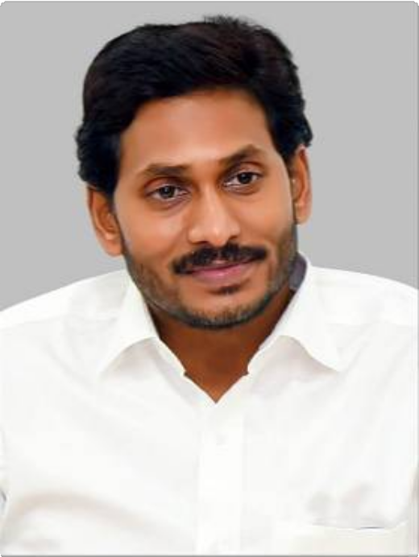

**Sri Y. S. Jagan Mohan Reddy Hon’ble Chief Minister**

**Andhra Pradesh**



[(https://sche.ap.gov.in/)](https://sche.ap.gov.in/)

[(https://iur.ls/careeredge_st)](https://iur.ls/careeredge_st)

[(https://ccelms.ap.gov.in/rusa/user/gpapers)](https://ccelms.ap.gov.in/rusa/user/gpapers)

[(/DOWGR2)](http://www.apcce.gov.in/DOWGR2)

[**Downloads**](http://www.apcce.gov.in/DOWL)

[**Academic Repository**](http://www.apcce.gov.in/DOWGR2)

[**CCE Learning Management System**](https://ccelms.ap.gov.in/rusa/user/gpapers)

[**JKC-TCS iON CAREER SKILLS COURSE**](https://iur.ls/careeredge_st)

[**Click here for Online Admissions 2021-22**](https://sche.ap.gov.in/)

**CCE Web News : Form for uploading Lesson Plan is enabled. Click on Academic Repository for uploading. CCE Web News : F**

[**Data submission : Login for Colleges (/DOWGR1)**](http://www.apcce.gov.in/DOWGR)

[**Data Reports : Login for Colleges (/DOWGR)**](http://www.apcce.gov.in/DOWGR)[**AC-Login (/ACL)**](http://www.apcce.gov.in/ACL)

[(/DOWL)](http://www.apcce.gov.in/DOWL)

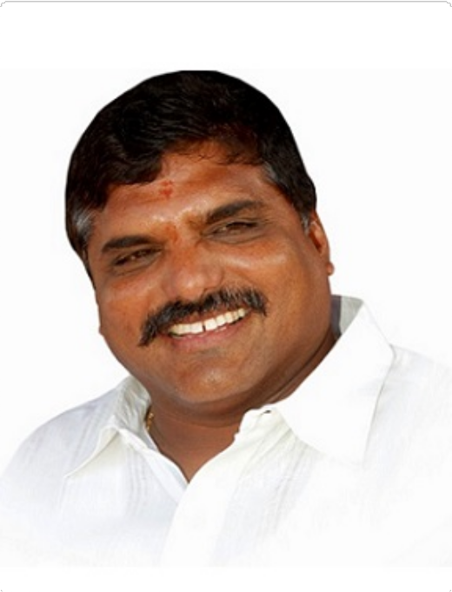

**Sri Botcha Satyanarayana**

**Hon’ble Minister for Education Andhra Pradesh**

ASAR 2020-21 Abstract

## ASAR 2020-21 Abstract

**Uploaded so far (Total : 2843**)

|  |  |  |  |  |  |  |  |  |  |  |  |  |  |  |
| --- | --- | --- | --- | --- | --- | --- | --- | --- | --- | --- | --- | --- | --- | --- |
| **S.No** | | **District** | | | | **Name of the College** | | | | | | **Number of**  **Employees** | | |
| 1 | | ANANTAPUR | | | | GDC BUKKAPATNAM | | | | | | 11 | | |
| 2 | | ANANTAPUR | | | | GDC HINDUPUR | | | | | | 12 | | |
| 3 | | ANANTAPUR | | | | GDC KALYANDURG | | | | | | 12 | | |
| 4 | | ANANTAPUR | | | | GDC PENUGONDA | | | | | | 8 | | |
| 5 | | ANANTAPUR | | | | GDC TADIPATRI | | | | | | 6 | | |
| 6 | | ANANTAPUR | | | | GDC URVAKONDA | | | | | | 19 | | |
| 7 | | ANANTAPUR | | | | GDC(K.H) DHARMAVARAM | | | | | | 9 | | |
| 8 | | ANANTAPUR | | | | GDC(KTS) RAYADURG | | | | | | 3 | | |
| 9 | | ANANTAPUR | | | | GDC(M) ANANTAPUR | | | | | | 109 | | |
| 10 | | ANANTAPUR | | | | GDC(SKP) GUNTAKAL | | | | | | 22 | | |
| 11 | | ANANTAPUR | | | | GDC(STSN) KADIRI | | | | | | 13 | | |
| 12 | | ANANTAPUR | | | | GDC(SYTR) MADAKASIRA | | | | | | 10 | | |
| 13 | | ANANTAPUR | | | | GDC(W) ANANTAPUR | | | | | | 22 | | |
| 14 | | CHITTOOR | | | | GDC KALIKIRI | | | | | | 6 | | |
| 15 | | CHITTOOR | | | | GDC KARVETINAGARAM | | | | | | 4 | | |
|  | 1 | **2** | **3** | **4** | **5** | | **6** | **7** | **8** | **9** | **10** | | **...** |  |

# Submitted Reports by the Principal - Readers & Lecturers

|  |  |  |  |  |  |  |  |  |  |  |  |  |  |
| --- | --- | --- | --- | --- | --- | --- | --- | --- | --- | --- | --- | --- | --- |
| **S.No** | **College** | **District** | **Name** | **Subject** | | **Teaching** | **Activities:**  **Administrative, Professional Development**  **etc** | **Overall Grade** | **Research Papers**  **Published** | **Publications excluding Research**  **Papers** | **Creation of ICT** | **Research Guidance** | **Re Pr**  **Co** |
| 1 | GDC BUKKAPATNAM | ANANTAPUR | S CHANDRA MOHAN | Commerce | | Good | Good | Good | 0 | 0 | 2 | 0 |  |
| 2 | GDC BUKKAPATNAM | ANANTAPUR | T NAGENDRA | Commerce | | Good | Good | Good | 0 | 0 | 4 | 0 |  |
| 3 | GDC BUKKAPATNAM | ANANTAPUR | V ANANDA KUMAR | Commerce | | Good | Good | Good | 0 | 0 | 4 | 0 |  |
| 4 | GDC BUKKAPATNAM | ANANTAPUR | ADASTAGIRI | Economics | | Good | Good | Good | 0 | 0 | 2 | 0 |  |
| 5 | GDC BUKKAPATNAM | ANANTAPUR | J PENCHALAIAH | English | | Good | Good | Good | 0 | 0 | 2 | 0 |  |
| 6 | GDC BUKKAPATNAM | ANANTAPUR | T VENKATAKRISHNAIAH | History | | Good | Good | Good | 0 | 0 | 2 | 0 |  |
| 7 | GDC BUKKAPATNAM | ANANTAPUR | R VENKATESWARA  PRASAD | Library  Science | | Good | Good | Good | 0 | 0 | 0 | 0 |  |
| 8 | GDC BUKKAPATNAM | ANANTAPUR | MC OBAIAH | Political  Science | | Good | Good | Good | 0 | 0 | 2 | 0 |  |
| 9 | GDC BUKKAPATNAM | ANANTAPUR | DR R N RAVI KUMAR | Telugu | | Good | Good | Good | 2 | 1 | 2 | 0 |  |
| 10 | GDC BUKKAPATNAM | ANANTAPUR | K SUNDARA MOHAN  REDDY | Telugu | | Good | Good | Good | 0 | 0 | 2 | 0 |  |
| 11 | GDC HINDUPUR | ANANTAPUR | G Bhojappa | Botany | | Good | Good | Good | 00 | 00 | 00 | 24 |  |
| 12 | GDC HINDUPUR | ANANTAPUR | G Venkatesulu | Chemistry | | Good | Good | Good | 00 | 00 | 64 | 00 |  |
| 13 | GDC HINDUPUR | ANANTAPUR | N Parvathi | Computer  Science | | Good | Good | Good | 00 | 00 | 48 | 00 |  |
| 14 | GDC HINDUPUR | ANANTAPUR | Dr B Yasoda Rani | English | | Good | Good | Good | 00 | 00 | 110 | 00 |  |
| 15 | GDC HINDUPUR | ANANTAPUR | Dr M Yasoda Devi | Hindi | | Good | Good | Good | 00 | 00 | 20 | 00 |  |
| 16 | GDC HINDUPUR | ANANTAPUR | Dr E Sreedher | History | | Good | Good | Good | 00 | 00 | 10 | 00 |  |
| 17 | GDC HINDUPUR | ANANTAPUR | Dr S Sreelakshmi | Mathematics | | Good | Good | Good | 00 | 00 | 110 | 00 |  |
| 18 | GDC HINDUPUR | ANANTAPUR | Dr P Saraswathi | Physics | | Good | Good | Good | 100 | 00 | 10 | 00 |  |
| 19 | GDC HINDUPUR | ANANTAPUR | B Ravi Naik | Political |  | Good | Good | Good | 00 | 00 | 40 | 00 |  |
| Science |
| 20 | GDC HINDUPUR | ANANTAPUR | C Sumangali | Statistics | | Good | Good | Good | 00 | 00 | 50 | 00 |  |
| 21 | GDC HINDUPUR | ANANTAPUR | Dr T A Thirumalamma | Zoology | | Good | Good | Good | 00 | 00 | 24 | 00 |  |
| 22 | GDC KALYANDURG | ANANTAPUR | C PRABHAKARA RAJU | Botany | | Good | Good | Good | 10 | 0 | 0 | 0 |  |
| 23 | GDC KALYANDURG | ANANTAPUR | P SASHIKIRAN | Botany | | Good | Good | Good | 65 | 0 | 5 | 0 |  |
| 24 | GDC KALYANDURG | ANANTAPUR | PS LAKSHMI | Economics | | Good | Good | Good | 0 | 0 | 12 | 0 |  |
| 25 | GDC KALYANDURG | ANANTAPUR | M V SESHAIAH | Economics | | Good | Good | Good | 0 | 0 | 142 | 0 |  |
| 26 | GDC KALYANDURG | ANANTAPUR | M INDIRAMMA | English | | Good | Good | Good | 0 | 0 | 40 | 0 |  |
| 27 | GDC KALYANDURG | ANANTAPUR | T N SREENIVASULU | History | | Satisfactory | Satisfactory | Satisfactory | 0 | 0 | 0 | 0 |  |
| 28 | GDC KALYANDURG | ANANTAPUR | D EMAMVALI | Mathematics | | Good | Satisfactory | Good | 0 | 0 | 0 | 0 |  |
| 29 | GDC KALYANDURG | ANANTAPUR | P SURYA NAGI REDDY | Physics | | Good | Good | Good | 60 | 0 | 20 | 0 |  |
| 30 | GDC KALYANDURG | ANANTAPUR | D CHANDRA SEKHAR | Physics | | Good | Good | Good | 55 | 0 | 20 | 0 |  |
| 31 | GDC KALYANDURG | ANANTAPUR | B SREEDEVI | Zoology | | Good | Good | Good | 0 | 0 | 145 | 0 |  |
| 32 | GDC KALYANDURG | ANANTAPUR | G L N PRASAD | Zoology | | Good | Good | Good | 0 | 05 | 200 | 0 |  |
| 33 | GDC PENUGONDA | ANANTAPUR | K SREEDEVI | Botany | | Good | Good | Good | 0 | 0 | 9 | 0 |  |
| 34 | GDC PENUGONDA | ANANTAPUR | N Hari prasad | Hindi | | Good | Good | Good | 0 | 0 | 30 | 0 |  |
| 35 | GDC PENUGONDA | ANANTAPUR | G Chennareddy | Physics | | Good | Good | Good | 0 | 0 | 0 | 0 |  |
| 36 | GDC PENUGONDA | ANANTAPUR | M VENUGOPALA RAO | Physics | | Good | Good | Good | 0 | 0 | 0 | 0 |  |
| 37 | GDC PENUGONDA | ANANTAPUR | C Hemamaruthi | Telugu | | Good | Good | Good | 0 | 0 | 0 | 0 |  |
| 38 | GDC PENUGONDA | ANANTAPUR | K HARISH BABU | Zoology | | Good | Good | Good | 10 | 0 | 20 | 0 |  |
| 39 | GDC PENUGONDA | ANANTAPUR | K JAYAPPA | Zoology | | Good | Good | Good | 0 | 0 | 33 | 0 |  |

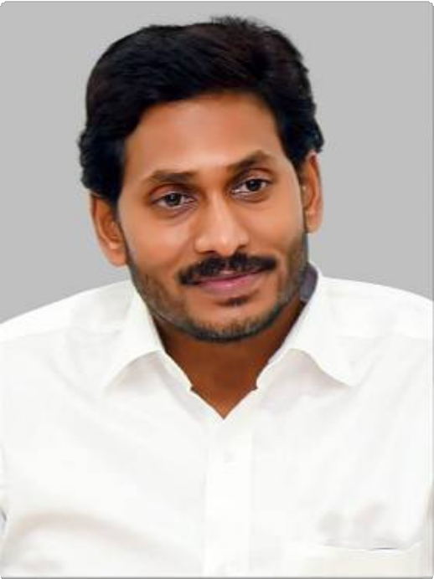

**Sri Y. S. Jagan Mohan Reddy Hon’ble Chief Minister**

**Andhra Pradesh**



[(https://sche.ap.gov.in/)](https://sche.ap.gov.in/)

[(https://iur.ls/careeredge_st)](https://iur.ls/careeredge_st)

[(https://ccelms.ap.gov.in/rusa/user/gpapers)](https://ccelms.ap.gov.in/rusa/user/gpapers)

[(/DOWGR2)](http://www.apcce.gov.in/DOWGR2)

[**Downloads**](http://www.apcce.gov.in/DOWL)

[**Academic Repository**](http://www.apcce.gov.in/DOWGR2)

[**CCE Learning Management System**](https://ccelms.ap.gov.in/rusa/user/gpapers)

[**JKC-TCS iON CAREER SKILLS COURSE**](https://iur.ls/careeredge_st)

[**Click here for Online Admissions 2021-22**](https://sche.ap.gov.in/)

**CCE Web News : Form for uploading Lesson Plan is enabled. Click on Academic Repository for uploading. CCE Web News : F**

[**Data submission : Login for Colleges (/DOWGR1)**](http://www.apcce.gov.in/DOWGR)

[**Data Reports : Login for Colleges (/DOWGR)**](http://www.apcce.gov.in/DOWGR)[**AC-Login (/ACL)**](http://www.apcce.gov.in/ACL)

[(/DOWL)](http://www.apcce.gov.in/DOWL)

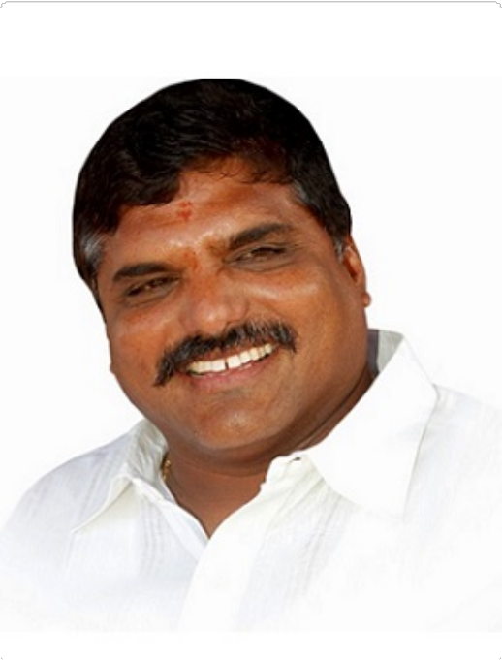

**Sri Botcha Satyanarayana**

**Hon’ble Minister for Education Andhra Pradesh**

ASAR 2019-20 Abstract

## ASAR 2019-20 Abstract

**Uploaded so far (Total : 3057**)

|  |  |  |  |  |  |  |  |  |  |  |  |  |  |  |
| --- | --- | --- | --- | --- | --- | --- | --- | --- | --- | --- | --- | --- | --- | --- |
| **S.No** | | **District** | | | | **Name of the College** | | | | | | **Number of**  **Employees** | | |
| 1 | | ANANTAPUR | | | | GDC BUKKAPATNAM | | | | | | 7 | | |
| 2 | | ANANTAPUR | | | | GDC HINDUPUR | | | | | | 17 | | |
| 3 | | ANANTAPUR | | | | GDC KALYANDURG | | | | | | 17 | | |
| 4 | | ANANTAPUR | | | | GDC PENUGONDA | | | | | | 14 | | |
| 5 | | ANANTAPUR | | | | GDC TADIPATRI | | | | | | 9 | | |
| 6 | | ANANTAPUR | | | | GDC URVAKONDA | | | | | | 20 | | |
| 7 | | ANANTAPUR | | | | GDC(K.H) DHARMAVARAM | | | | | | 7 | | |
| 8 | | ANANTAPUR | | | | GDC(KTS) RAYADURG | | | | | | 8 | | |
| 9 | | ANANTAPUR | | | | GDC(M) ANANTAPUR | | | | | | 86 | | |
| 10 | | ANANTAPUR | | | | GDC(SKP) GUNTAKAL | | | | | | 15 | | |
| 11 | | ANANTAPUR | | | | GDC(STSN) KADIRI | | | | | | 15 | | |
| 12 | | ANANTAPUR | | | | GDC(SYTR) MADAKASIRA | | | | | | 7 | | |
| 13 | | ANANTAPUR | | | | GDC(W) ANANTAPUR | | | | | | 16 | | |
| 14 | | ANANTAPUR | | | | SDGS COLLEGE, HINDUPUR | | | | | | 8 | | |
| 15 | | ANANTAPUR | | | | SRI SAI BABA NATIONAL COLLEGE  ANANTHAPUR | | | | | | 3 | | |
|  | 1 | **2** | **3** | **4** | **5** | | **6** | **7** | **8** | **9** | **10** | | **...** |  |

# Submitted Reports by the Principal - Readers & Lecturers

|  |  |  |  |  |  |  |  |  |  |  |  |  |
| --- | --- | --- | --- | --- | --- | --- | --- | --- | --- | --- | --- | --- |
| **S.No** | **College** | **District** | **Name** | **Subject** | **Teaching** | **Activities:**  **Administrative, Professional Development**  **etc** | **Overall Grade** | **Research Papers**  **Published** | **Publications excluding Research**  **Papers** | **Creation of ICT** | **Research Guidance** | **Res Pro Com** |
| 1 | GDC BUKKAPATNAM | ANANTAPUR | S CHANDRA MOHAN | Commerce | Good | Satisfactory | Good | 0 | 0 | 20 | 0 |  |
| 2 | GDC BUKKAPATNAM | ANANTAPUR | Dr U SANKARA | Economics | Good | Good | Good | 0 | 0 | 20 | 0 |  |
| 3 | GDC BUKKAPATNAM | ANANTAPUR | Dr G USHA RANI | English | Good | Good | Good | 0 | 0 | 20 | 0 |  |
| 4 | GDC BUKKAPATNAM | ANANTAPUR | B NAGABHUSHANA | History | Good | Good | Good | 0 | 0 | 35 | 0 |  |
| 5 | GDC BUKKAPATNAM | ANANTAPUR | M C OBAIAH | Political  Science | Good | Good | Good | 0 | 0 | 20 | 0 |  |
| 6 | GDC BUKKAPATNAM | ANANTAPUR | D RAMANNA | Telugu | Good | Satisfactory | Good | 0 | 0 | 20 | 0 |  |
| 7 | GDC BUKKAPATNAM | ANANTAPUR | Dr S SHAMIULLA | Telugu | Good | Good | Good | 0 | 10 | 20 | 0 |  |
| 8 | GDC HINDUPUR | ANANTAPUR | Dr S Salamma | Botany | Good | Good | Good | 15 | 0 | 14 | 0 |  |
| 9 | GDC HINDUPUR | ANANTAPUR | Y B Nagamani | Chemistry | Good | Good | Good | 10 | 0 | 146 | 0 |  |
| 10 | GDC HINDUPUR | ANANTAPUR | B Krishnaveni | Commerce | Good | Good | Good | 0 | 0 | 510 | 0 |  |
| 11 | GDC HINDUPUR | ANANTAPUR | B Krishnaveni | Commerce | Good | Good | Good | 0 | 0 | 85 | 0 |  |
| 12 | GDC HINDUPUR | ANANTAPUR | A Madhavi | Computer  Applications | Good | Good | Good | 0 | 0 | 133 | 0 |  |
| 13 | GDC HINDUPUR | ANANTAPUR | A Madhavi | Computer  Applications | Satisfactory | Satisfactory | Satisfactory | 0 | 0 | 133 | 0 |  |
| 14 | GDC HINDUPUR | ANANTAPUR | A Madhavi | Computer  Applications | Not  Satisfactory | Good | Not  Satisfactory | 0 | 0 | 133 | 0 |  |
| 15 | GDC HINDUPUR | ANANTAPUR | A Vineela | Computer  Science | Satisfactory | Satisfactory | Satisfactory | 0 | 0 | 20 | 0 |  |
| 16 | GDC HINDUPUR | ANANTAPUR | A Madhavi | Computer  Science | Good | Satisfactory | Good | 0 | 0 | 133 | 0 |  |
| 17 | GDC HINDUPUR | ANANTAPUR | Dr B Yashoda Rani | English | Satisfactory | Satisfactory | Satisfactory | 0 | 0 | 48 | 0 |  |
| 18 | GDC HINDUPUR | ANANTAPUR | G Neethamma | English | Satisfactory | Satisfactory | Satisfactory | 0 | 0 | 57 | 0 |  |
| 19 | GDC HINDUPUR | ANANTAPUR | Dr B Yashoda Rani | English | Not  Satisfactory | Not  Satisfactory | Not  Satisfactory | 0 | 0 | 48 | 0 |  |
| 20 | GDC HINDUPUR | ANANTAPUR | Dr Sane SreeLakshmi | Mathematics | Good | Good | Good | 0 | 0 | 35 | 0 |  |
| 21 | GDC HINDUPUR | ANANTAPUR | Dr B Rama subba Reddy | Physics | Satisfactory | Satisfactory | Satisfactory | 0 | 0 | 0 | 0 |  |
| 22 | GDC HINDUPUR | ANANTAPUR | Dr E Nagaraju | Telugu | Satisfactory | Satisfactory | Satisfactory | 0 | 0 | 0 | 0 |  |
| 23 | GDC HINDUPUR | ANANTAPUR | Dr E Nagaraju | Telugu | Not  Satisfactory | Not  Satisfactory | Not  Satisfactory | 0 | 0 | 0 | 0 |  |
| 24 | GDC HINDUPUR | ANANTAPUR | R Hemalatha | Zoology | Good | Good | Good | 0 | 0 | 140 | 0 |  |
| 25 | GDC KALYANDURG | ANANTAPUR | Dr P Akbar Basha | Botany | Good | Good | Good | 0 | 0 | 45 | 0 |  |
| 26 | GDC KALYANDURG | ANANTAPUR | K Y Narayana | Botany | Good | Good | Good | 0 | 0 | 45 | 0 |  |
| 27 | GDC KALYANDURG | ANANTAPUR | P HARSHALATHA | Chemistry | Good | Good | Good | 10 | 0 | 12 | 0 |  |
| 28 | GDC KALYANDURG | ANANTAPUR | T Venkataramana | Commerce | Good | Good | Good | 0 | 0 | 40 | 0 |  |
| 29 | GDC KALYANDURG | ANANTAPUR | K T Vijay Naik | Computer  Science | Good | Good | Good | 0 | 0 | 40 | 0 |  |
| 30 | GDC KALYANDURG | ANANTAPUR | Dr V MARY MADHURI | Economics | Good | Good | Good | 0 | 0 | 45 | 0 |  |
| 31 | GDC KALYANDURG | ANANTAPUR | D SASI KUMAR | English | Satisfactory | Satisfactory | Satisfactory | 0 | 0 | 70 | 0 |  |
| 32 | GDC KALYANDURG | ANANTAPUR | D EMAMVALI | Mathematics | Good | Good | Good | 0 | 0 | 10 | 0 |  |
| 33 | GDC KALYANDURG | ANANTAPUR | D UMAR SHARIF | Physics | Good | Good | Good | 0 | 0 | 0 | 0 |  |
| 34 | GDC KALYANDURG | ANANTAPUR | Dr M Akshuthanandh | Political  Science | Good | Good | Good | 0 | 0 | 50 | 0 |  |
| 35 | GDC KALYANDURG | ANANTAPUR | Dr Anke Sreenivasulu | Telugu | Good | Good | Good | 8 | 0 | 70 | 0 |  |
| 36 | GDC KALYANDURG | ANANTAPUR | M PARAMESH | Telugu | Good | Good | Good | 0 | 0 | 40 | 0 |  |
| 37 | GDC KALYANDURG | ANANTAPUR | Dr P GIRIDHAR | Zoology | Good | Good | Good | 10 | 0 | 30 | 0 |  |
| 38 | GDC KALYANDURG | ANANTAPUR | Dr N Venkatanarayana | Economics | Good | Good | Good | 25 | 0 | 45 | 0 |  |
| 39 | GDC KALYANDURG | ANANTAPUR | Dr N B Shama Bharathi | English | Good | Good | Good | 40 | 0 | 100 | 0 |  |

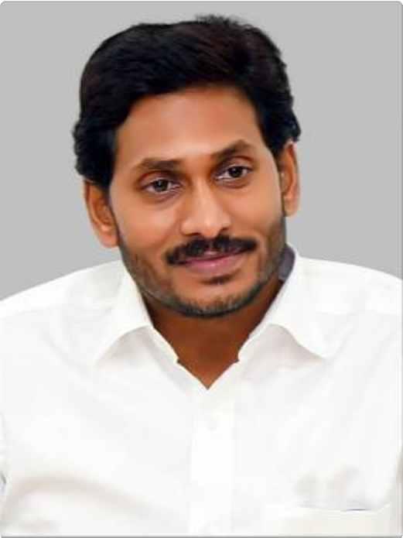

**Sri Y. S. Jagan Mohan Reddy Hon’ble Chief Minister**

**Andhra Pradesh**



[(https://sche.ap.gov.in/)](https://sche.ap.gov.in/)

[(https://iur.ls/careeredge_st)](https://iur.ls/careeredge_st)

[(https://ccelms.ap.gov.in/rusa/user/gpapers)](https://ccelms.ap.gov.in/rusa/user/gpapers)

[(/DOWGR2)](http://www.apcce.gov.in/DOWGR2)

[**Downloads**](http://www.apcce.gov.in/DOWL)

[**Academic Repository**](http://www.apcce.gov.in/DOWGR2)

[**CCE Learning Management System**](https://ccelms.ap.gov.in/rusa/user/gpapers)

[**JKC-TCS iON CAREER SKILLS COURSE**](https://iur.ls/careeredge_st)

[**Click here for Online Admissions 2021-22**](https://sche.ap.gov.in/)

**CCE Web News : Form for uploading Lesson Plan is enabled. Click on Academic Repository for uploading. CCE Web News : Form for upload**

[**Data submission : Login for Colleges (/DOWGR1)**](http://www.apcce.gov.in/DOWGR)

[**Data Reports : Login for Colleges (/DOWGR)**](http://www.apcce.gov.in/DOWGR)[**AC-Login (/ACL)**](http://www.apcce.gov.in/ACL)

[(/DOWL)](http://www.apcce.gov.in/DOWL)

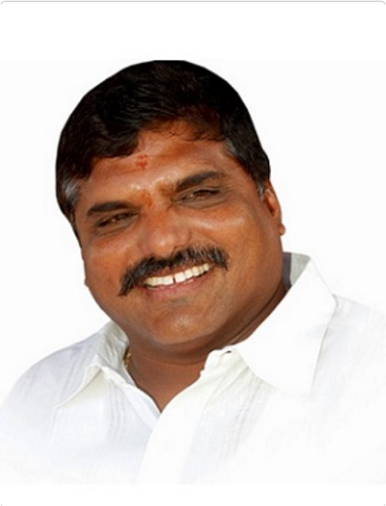

**Sri Botcha Satyanarayana**

**Hon’ble Minister for Education Andhra Pradesh**

ASAR Abstract

ASAR 2018-19

**Uploaded so far (Total : 3487**)

|  |  |  |  |  |  |  |  |  |  |  |  |  |  |  |
| --- | --- | --- | --- | --- | --- | --- | --- | --- | --- | --- | --- | --- | --- | --- |
| **S.No** | | **District** | | | | **Name of the College** | | | | | | **Number of**  **Employees** | | |
| 1 | | ANANTAPUR | | | | GDC BUKKAPATNAM | | | | | | 4 | | |
| 2 | | ANANTAPUR | | | | GDC HINDUPUR | | | | | | 13 | | |
| 3 | | ANANTAPUR | | | | GDC KALYANDURG | | | | | | 20 | | |
| 4 | | ANANTAPUR | | | | GDC PENUGONDA | | | | | | 15 | | |
| 5 | | ANANTAPUR | | | | GDC TADIPATRI | | | | | | 11 | | |
| 6 | | ANANTAPUR | | | | GDC URVAKONDA | | | | | | 15 | | |
| 7 | | ANANTAPUR | | | | GDC(K.H) DHARMAVARAM | | | | | | 11 | | |
| 8 | | ANANTAPUR | | | | GDC(KTS) RAYADURG | | | | | | 10 | | |
| 9 | | ANANTAPUR | | | | GDC(M) ANANTAPUR | | | | | | 90 | | |
| 10 | | ANANTAPUR | | | | GDC(SKP) GUNTAKAL | | | | | | 22 | | |
| 11 | | ANANTAPUR | | | | GDC(STSN) KADIRI | | | | | | 20 | | |
| 12 | | ANANTAPUR | | | | GDC(SYTR) MADAKASIRA | | | | | | 7 | | |
| 13 | | ANANTAPUR | | | | GDC(W) ANANTAPUR | | | | | | 15 | | |
| 14 | | ANANTAPUR | | | | SDGS COLLEGE, HINDUPUR | | | | | | 8 | | |
| 15 | | ANANTAPUR | | | | SRI SAI BABA NATIONAL COLLEGE  ANANTHAPUR | | | | | | 22 | | |
|  | 1 | **2** | **3** | **4** | **5** | | **6** | **7** | **8** | **9** | **10** | | **...** |  |

ASAR Scores based on Principal's Score

|  |  |  |  |  |  |  |  |  |  |  |  |  |  |  |
| --- | --- | --- | --- | --- | --- | --- | --- | --- | --- | --- | --- | --- | --- | --- |
| **S.No** | **Name of the College** | **DISTRICT** | **College Type** | **Name of the Employee** | **Subject** | | | **Cat-I Grade:**  **Principal** | **Cat-II Grade:**  **Principal** | **Cat-III**  **Grade (For Librarians/ Physical**  **Directors)**  **[OR]**  **Overall Grade (For Lecturers/ Readers) :**  **Principal** | **Cat-IV Grade:**  **Principal** | **Cat-V Grade:**  **Principal** | **Overall Grade (For Librarians/ Physical**  **Directors) :**  **Principal** | **Cat-III**  **Total (For Lecturers/ Readers)**  **: Principal** |
| 1 | GDC BUKKAPATNAM | ANANTAPUR | Government | Dr. U. Sankara | Economics | | | Good | Good | Good |  |  | 5 | 5 |
| 2 | GDC BUKKAPATNAM | ANANTAPUR | Government | G. Usha Rani | English | | | Good | Good | Good |  |  |  | 0 |
| 3 | GDC BUKKAPATNAM | ANANTAPUR | Government | B. Nagabushanam | History | | | Good | Good | Good | 20 |  |  | 26 |
| 4 | GDC BUKKAPATNAM | ANANTAPUR | Government | Dr. S. Shamiulla | Telugu | | | Good | Good | Good |  | 25 | 5 | 51 |
| 5 | GDC HINDUPUR | ANANTAPUR | Government | N.S.P.R GDC for WOMEN | 0 | | | Good | Good | Good | 0 |  |  | 0 |
| 6 | GDC HINDUPUR | ANANTAPUR | Government | Dr.Salamma.S | Botany | | | Good | Good | Good | 20 |  | 5 | 30 |
| 7 | GDC HINDUPUR | ANANTAPUR | Government | Y.B.Nagamani | Chemistry | | | Good | Good | Good | 11 |  | 5 | 16 |
| 8 | GDC HINDUPUR | ANANTAPUR | Government | N.S.P.R GDC for WOMEN | Commerce | | | Good | Good | Good |  |  | 5 | 5 |
| 9 | GDC HINDUPUR | ANANTAPUR | Government | Madhavi Alamuri | Computer  Applications | | | Good | Good | Good |  |  | 5 | 8 |
| 10 | GDC HINDUPUR | ANANTAPUR | Government | Veneela | Computer  Science | | | Good | Good | Good | 05 |  | 5 | 10 |
| 11 | GDC HINDUPUR | ANANTAPUR | Government | Dr. K.Prabhakar Reddy | English | | | Good | Good | Good | 35 |  | 5 | 40 |
| 12 | GDC HINDUPUR | ANANTAPUR | Government | Yasoda Rani | English | | | Good | Good | Good | 0 | 0 | 0 | 0 |
| 13 | GDC HINDUPUR | ANANTAPUR | Government | Dr. S.Sreelakshmi | Mathematics | | | Good | Good | Good | 0 | 0 | 5 | 15 |
| 14 | GDC HINDUPUR | ANANTAPUR | Government | Dr.B.Ramasubba Reddy | Physics | | | Good | Good | Good | 0 |  | 5 | 5 |
| 15 | GDC HINDUPUR | ANANTAPUR | Government | Dr. K.Prabhakar Reddy |  | Political |  | Good | Good | Good | 35 |  | 5 | 40 |
| Science |
| 16 | GDC HINDUPUR | ANANTAPUR | Government | Dr.E.Nagaraju | Telugu | | | Good | Good | Good | 0 | 0 | 5 | 5 |
| 17 | GDC HINDUPUR | ANANTAPUR | Government | EMALATHA | Zoology | | | Good | Good | Good |  |  | 5 | 5 |
| 18 | GDC KALYANDURG | ANANTAPUR | Government | K.Y.Narayana | Botany | | | Good | Good | Good | 00 | 00 | 00 | 6 |
| 19 | GDC KALYANDURG | ANANTAPUR | Government | Dr P.Akbar basha | Botany | | | Good | Good | Good | 00 | 00 | 38 | 41 |
| 20 | GDC KALYANDURG | ANANTAPUR | Government | M.G.Gopikrishnakumari | Botany | | | Good | Good | Good | 00 | 00 | 00 | 3 |
| 21 | GDC KALYANDURG | ANANTAPUR | Government | M.Pragathi | Chemistry | | | Good | Good | Good | 10 | 0 | 80 | 96 |
| 22 | GDC KALYANDURG | ANANTAPUR | Government | Dr M.Pragathi | Chemistry | | | Good | Good | Good |  |  |  |  |
| 23 | GDC KALYANDURG | ANANTAPUR | Government | P.Harshalatha | Chemistry | | | Good | Good | Good | 30 | 00 | 07 | 42 |
| 24 | GDC KALYANDURG | ANANTAPUR | Government | G.Nagabhushanam | Commerce | | | Good | Good | Good | 00 | 00 | 86 | 92 |
| 25 | GDC KALYANDURG | ANANTAPUR | Government | T.Venkata Ramana | Commerce | | | Good | Good | Good | 00 | 00 | 86 | 95 |
| 26 | GDC KALYANDURG | ANANTAPUR | Government | K.T.Vijay Naik | Computer  Applications | | | Good | Good | Good | 00 | 00 | 86 | 89 |
| 27 | GDC KALYANDURG | ANANTAPUR | Government | Dr V.Marymadhuri | Economics | | | Good | Good | Good | 05 | 00 | 79 | 90 |
| 28 | GDC KALYANDURG | ANANTAPUR | Government | Dr N.Venkatanarayana | Economics | | | Good | Good | Good | 18 | 00 | 79 | 100 |
| 29 | GDC KALYANDURG | ANANTAPUR | Government | Dr N.B.Shamabharathi | English | | | Good | Good | Good | 00 | 00 | 125 | 131 |
| 30 | GDC KALYANDURG | ANANTAPUR | Government | T.N.Sreenivasulu | History | | | Good | Good | Good | 00 | 00 | 62 | 65 |
| 31 | GDC KALYANDURG | ANANTAPUR | Government | D.Emamvali | Mathematics | | | Good | Good | Good | 00 | 00 | 62 | 65 |
| 32 | GDC KALYANDURG | ANANTAPUR | Government | Dr B.Sasikala Devi | Physics | | | Good | Good | Good | 00 | 00 | 07 | 10 |
| 33 | GDC KALYANDURG | ANANTAPUR | Government | Dr M.Akshuthanandh | Political  Science | | | Good | Good | Good | 00 | 00 | 38 | 46 |
| 34 | GDC KALYANDURG | ANANTAPUR | Government | Dr N.Ramesh Reddy | Political  Science | | | Good | Good | Good | 35 | 00 | 38 | 79 |
| 35 | GDC KALYANDURG | ANANTAPUR | Government | DR. ANKE SREENIVASULU | Telugu | | | Good | Good | Good | 00 | 00 | 24 | 46 |
| 36 | GDC KALYANDURG | ANANTAPUR | Government | J.Pandari Devi | Zoology | | | Good | Good | Good | 00 | 00 | 04 | 7 |
| 37 | GDC KALYANDURG | ANANTAPUR | Government | Dr P.Giridhar | Zoology | | | Good | Good | Good | 20 | 00 | 00 | 26 |
| 38 | GDC KALYANDURG | ANANTAPUR | Select | M.Pragathi | Chemistry | | | Good | Good | Good | 10 | 00 | 80 | 96 |
| 39 | GDC PENUGONDA | ANANTAPUR | Government | A.NARAYANA SWAMY | Botany | | | Good | Good | Good | 00 | 00 | 125 | 125 |
| 40 | GDC PENUGONDA | ANANTAPUR | Government | Dr.P.RAMAKRISHNA | Chemistry | | | Good | Good | Good | 0 | 0 | 105 | 107 |
| 41 | GDC PENUGONDA | ANANTAPUR | Government | N.ANJANEYULU | Chemistry | | | Good | Good | Good | 0 | 0 | 20 | 20 |
| 42 | GDC PENUGONDA | ANANTAPUR | Government | K.MALLIKARJUNA RAO | Commerce | | | Good | Good | Good | 0 | 0 | 100 | 106 |
| 43 | GDC PENUGONDA | ANANTAPUR | Government | Dr.M.BALAJI NAIK | Economics | | | Good | Good | Good | 0 | 0 | 150 | 159 |
| 44 | GDC PENUGONDA | ANANTAPUR | Government | NARASIMHAM. M.V.L. | Hindi | | | Good | Satisfactory | Good | 0 | 0 | 100 | 114 |
| 45 | GDC PENUGONDA | ANANTAPUR | Government | K.NAGABHUSHANAM | History | | | Good | Good | Good | 0 | 0 | 100 | 108 |
| 46 | GDC PENUGONDA | ANANTAPUR | Government | Dr.P.KESHALU | Library  Science | | | Good | Not  Satisfactory | Satisfactory | Good | Good | Good |  |
| 47 | GDC PENUGONDA | ANANTAPUR | Government | K.SREENIVASA PRASAD | Physical  Education | | | Good | Good | Good | Satisfactory | Good | Good |  |
| 48 | GDC PENUGONDA | ANANTAPUR | Government | G.CHENNA REDDY | Physics | | | Good | Good | Good | 0 | 0 | 0 | 0 |
| 49 | GDC PENUGONDA | ANANTAPUR | Government | K.CHOWDAPPA | Political Science | | | Good | Good | Good | 0 | 0 | 50 | 50 |
| 50 | GDC PENUGONDA | ANANTAPUR | Government | C.HEMA MARUTHI | Telugu | | | Good | Satisfactory | Good | 0 | 0 | 0 | 0 |
| 51 | GDC PENUGONDA | ANANTAPUR | Government | Dr K JAYAPPA | Zoology | | | Good | Good | Good | 0 | 0 |  | 0 |
| 52 | GDC PENUGONDA | ANANTAPUR | Government | Dr.K.HARISH BABU | Zoology | | | Good | Good | Good | 0 | 0 | 130 | 132 |
| 53 | GDC PENUGONDA | ANANTAPUR | Government | K JAYAPPA | Zoology | | | Good | Good | Good |  |  | 125 | 137 |
| 54 | GDC TADIPATRI | ANANTAPUR | Government | Dr. E. Sreedevi | Botany | | | Good | Good | Good | 14 | 0 | 67 | 108 |
| 55 | GDC TADIPATRI | ANANTAPUR | Government | S.B. Sujatha | Chemistry | | | Good | Good | Good | 0 | 0 | 0 | 6 |
| 56 | GDC TADIPATRI | ANANTAPUR | Government | Dr. U Raghavendra Prasad | Commerce | | | Good | Good | Good | 0 | 0 | 0 | 6 |
| 57 | GDC TADIPATRI | ANANTAPUR | Government | H.Sivasankar | Economics | | | Good | Good | Good | 0 | 0 | 40 | 48 |
| 58 | GDC TADIPATRI | ANANTAPUR | Government | Sri B.Praveen Kumar | English | | | Good | Good | Good | 0 | 0 | 10 | 16 |
| 59 | GDC TADIPATRI | ANANTAPUR | Government | K.Mahendra Rao | Library  Science | | | Good | Not  Satisfactory | Satisfactory | Good | Good | Good |  |
| 60 | GDC TADIPATRI | ANANTAPUR | Government | A.C. Venkata Ramudu | Mathematics | | | Good | Good | Good | 0 | 0 | 5 | 10 |
| 61 | GDC TADIPATRI | ANANTAPUR | Government | V. Thimmareddy | Physics | | | Good | Good | Good | 0 | 0 | 35 | 46 |
| 62 | GDC TADIPATRI | ANANTAPUR | Government | Sri A.Narayanaswamy | Political  Science | | | Good | Good | Good | 0 | 0 | 30 | 36 |
| 63 | GDC TADIPATRI | ANANTAPUR | Government | Vankam Bhaskar | Political  Science | | | Good | Good | Good | 0 | 15 | 50 | 69 |
| 64 | GDC TADIPATRI | ANANTAPUR | Government | Vankam Bhaskar | Telugu | | | Good | Good | Good | 0 | 15 | 50 | 69 |
| 65 | GDC URVAKONDA | ANANTAPUR | Government | B Bhavani | Botany | | | Good | Good | Good | 0 | 0 | 0 | 0 |
| 66 | GDC URVAKONDA | ANANTAPUR | Government | K Srinivasulu | Chemistry | | | Good | Good | Good | 0 | 0 | 0 | 0 |
| 67 | GDC URVAKONDA | ANANTAPUR | Government | Dr.G.Sailaja | Chemistry | | | Good | Good | Good | 20 | 05 | 52 | 82 |
| 68 | GDC URVAKONDA | ANANTAPUR | Government | C Ravindra Reddy | Commerce | | | Good | Good | Good | 0 | 0 | 0 | 6 |

